

K4 CSF3133 REKA BENTUK ANTARA MUKA BERASASKAN WEB
LAB REPORT 2
SEMESTER 3

PREPARED FOR: ASSOC. PROF. TS. DR. WAN NURAL JAWAHIR
LAB ASSISTANT: MISS WAN FATIN

PREPARED BY: AKMA ASYIFA BINTI ZULKARNAIE
NO. MATRIC: S75186
SUBMISSION DATE: 29 OCTOBER 2025

Lab 2- Introduction to HTML

2.3 Working with Tables

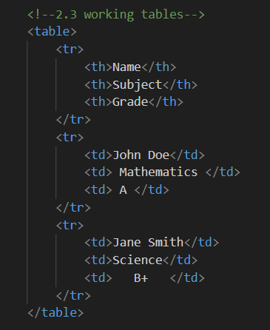
Figure 1.1 Code
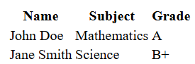
Figure 1.2 Table result

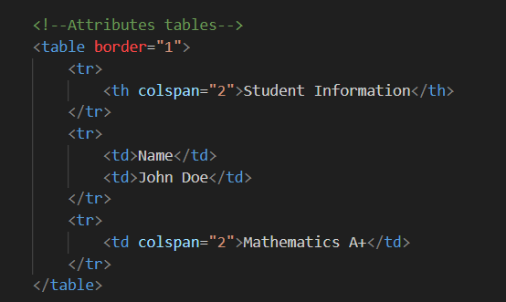
Figure 1.3 Code
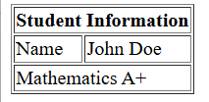
Figure 1.4 The result

2.4 Creating Forms
2.4.1 Basic Form Elements
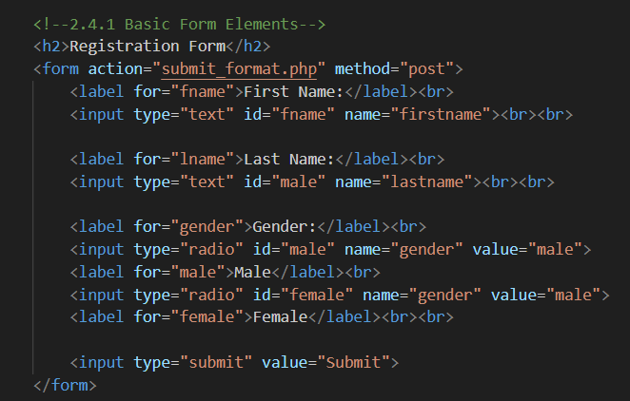
Figure 1.5 Code form
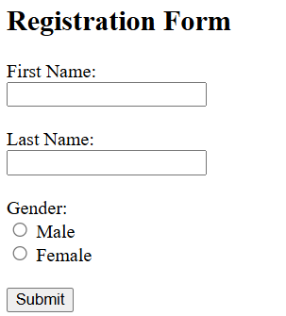
Figure 1.6 Result form

2.4.2 Other Form Elements
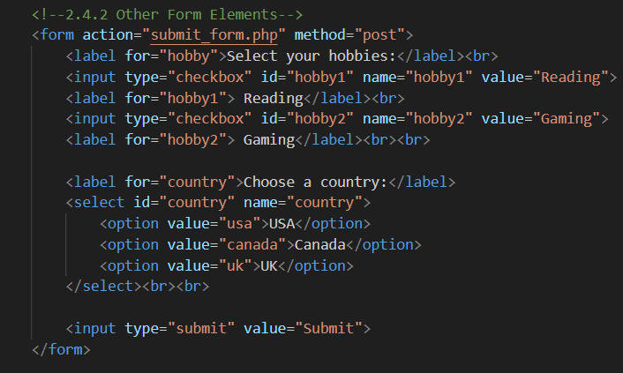
Figure 1.7 Code other form
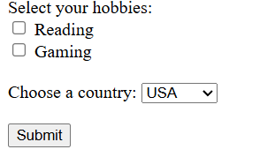
Figure 1.8 Result form

2.5 Semantic HTML

2.5.1 Common Semantic Tags

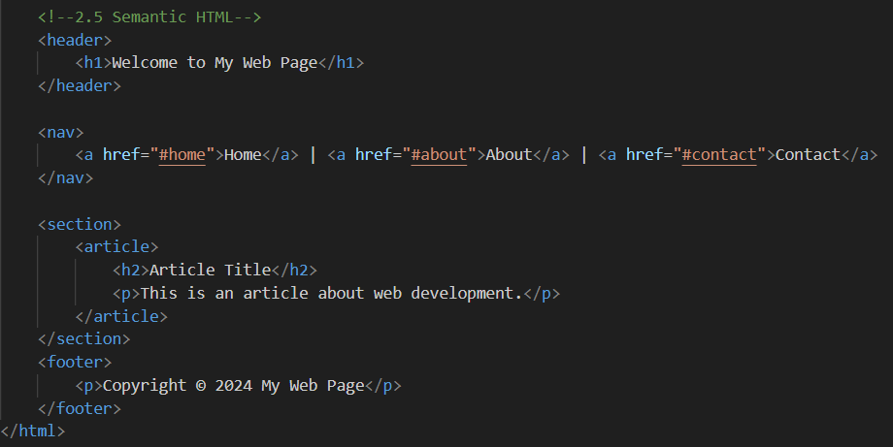
Figure 1.9 Code semantic

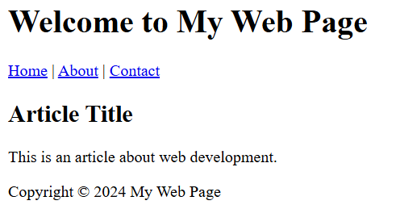
Figure 2.0 Result semantic

2.6 Lab Exercise 2
2.6.1 Building a Personal Profile Page

Code:
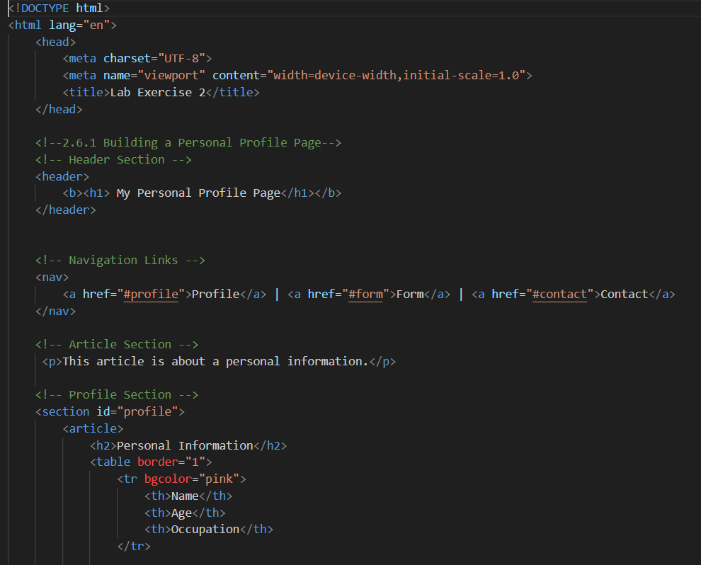
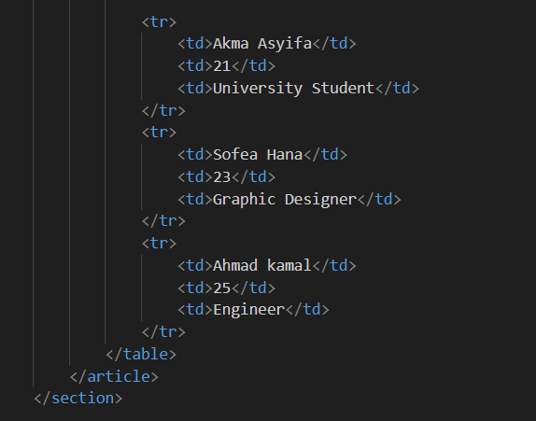

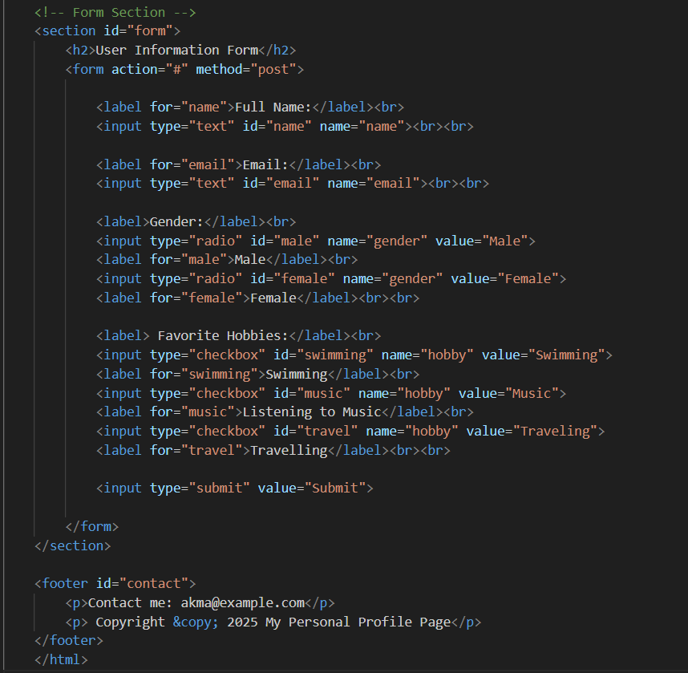

Result:
